Q1. If 'A' stands for '÷', 'B' stands for '−', 'C' stands for '×', and 'D' stands for '+', what will come in place of the question mark (?) in the following equation: 36 B 8 A 56 C 49 D 53 = ?

a. 53

b. 82

c. 46

d. 30

Ans. B

Sol. Substituting the symbols, the equation becomes 36−8÷56×49+53. Following order of operations: 8÷56=1/7, (1/7)×49=7, 36−7+53=29+53=82.

Q2. The position of how many letters will change if each of the letters in the word SKYLINE is arranged in alphabetical order?

a. Seven

b. Six

c. Five

d. Four

Ans. B

Sol. SKYLINE in alphabetical order is EIKLNSY. Comparing with the original, the positions of S, K, Y, I, N, and E have changed. Thus, six letters change their position.

Q3. 'RENT' is related to 'IVMG' and 'PAYABLE' is related to 'KZBYOYV' based on the English alphabetical order. How is 'BARGANDY' related?

a. YZITFAMWB

b. YZITVZWMB

c. YZITFZWMB

d. YZITFZMYB

Ans. C

Sol. The pattern is that each letter is replaced by its opposite letter in the alphabet (e.g., A-Z, B-Y). Applying this to 'BARGANDY' gives YZITZMWB.

Q4. How many triangles are there in the given figure?

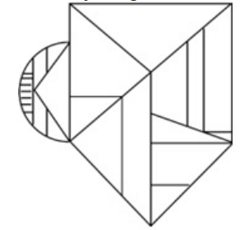

a. 13

b. 11

c. 10

d. 12

Ans. D

Sol. Counting carefully reveals 12 triangles.

Q5. What will come in place of '?' in the following equation, if '×' and '+' are interchanged? 45×9+23−16+7=?

a. 140

b. −79

c. −64

d. −76

Ans. A

Sol. Interchanged: 45+9×23−16×7=

Q6. 15 is related to 195, 19 is related to 247. How is 24 related?

a. 322

b. 332

c. 300

d. 312

Ans. D

Sol. Pattern: n×13=result. 15×13=195, 19×13=247, so 24×13=312.

Q7. What should come in place of the question mark (?) in the given series? 160, 187, 216, 247, ?

a. 290

b. 280

c. 209

d. 208

Ans. B

Sol. Differences are +27, +29, +31. Next difference is +33. 247+33=280.

Q8. In a certain code language,

‘A+ B’ means ‘A is the son of B’,

‘A – B’ means ‘A is the brother of B’,

‘A × B’ means ‘A is the wife of B’,

‘A ÷ B’ means ‘A is the daughter of B’.

How is L related to M if 'L - N ÷ O × M + P'?

a. Father's father

b. Brother

c. Son

d. Father

Ans. C

Sol. L is brother of N, N is daughter of O (O is father of L), O is wife of M (M is father of L). Thus, L is the son of M.

Q9.In a certain code language, 'my best friend' is written as 'ck rl mk' and 'friend is life' is written as 'rt mp ck'. How is 'friend' written in the given language?

a. rt

b. ck

c. rl

d. mk

Ans. B

Sol. Common word 'friend' corresponds to the common code 'ck'.

Q10. Select the option figure in which the given figure (X) is embedded as its part (rotation is NOT allowed)**.**



1. 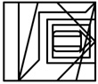

1. 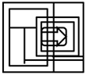
2. 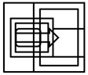
3. 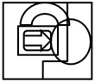

Ans. a

Sol. Match With the solutions

Q11.

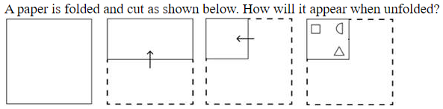

1. 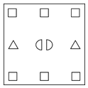
2. 
3. 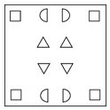
4. 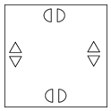

Ans. c

Sol. Match With the solutions

Q12.Identify the figure in the options that when put in place of the question mark (?) will logically complete the series?

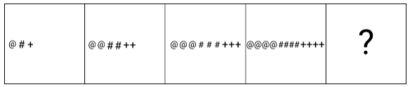

1. 
2. 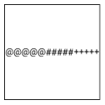
3. 
4. 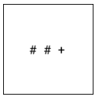

Ans. b

Sol. Match With the solutions

Q13. What should come in place of the question mark (?) in the given series? 23, 44, 65, 86, ?, 128

a. 103

b. 109

c. 107

d. 105

Ans. C

Sol. The difference between consecutive terms is consistently 21 (44−23=21, 65−44=21, 86−65=21). Therefore, the next term is 86+21=107.

Q14. The position of how many letters will remain unchanged if each of the letters in the word COMPLEXITY is arranged from left to right in alphabetical order?

a. One

b. Two

c. None

d. Three

Ans. B

Sol. The letters in COMPLEXITY are C, O, M, P, L, E, X, I, T, Y. In alphabetical order, they are C, E, I, L, M, O, P, T, X, Y. Comparing the original and the sorted word, 'C' is at the first position in both, and 'P' is at the seventh position in both. Thus, the position of two letters remains unchanged.

Q15. Read the given statements and conclusions carefully. Assuming that the information given in the statements is true, even if it appears to be at variance with commonly known facts, decide which of the given conclusions logically follows(s) 1 from the statements.

Statements: 2

Some laptops are computers.

No computer is a robot.

Some robots are humans.

Conclusions:

(I) All humans can never be computers.

(II) Some robots are laptops.

a. Only conclusion II follows

b. Only conclusion I follows

c. Both conclusions I and II follow

d. None of the conclusions follow

Ans. B

Sol. Let's analyze the conclusions based on the statements:

Conclusion (I): All humans can never be computers. We know that some robots are humans, and no computer is a robot. This implies that the set of computers and the set of robots are entirely separate. Since some humans are robots, these humans cannot be computers. However, the statements do not provide information to conclude that all humans can never be computers.

Conclusion (II): Some robots are laptops. We know that some laptops are computers, and no computer is a robot. This means there is no overlap between the set of computers and the set of robots. Therefore, it is impossible for any robot to be a laptop. Based on this analysis, only conclusion I logically follows.

Q16. What should come in place of the question mark (?) in the given series based on the English alphabetical order? BRK, XUH, TXE, PAB, ?

a. NCX

b. MDX

c. LDY

d. MCZ

Ans. C

Sol. Let's analyze the pattern in the first letters: B (-2) → X (-4) → T (-4) → P (-4) → L.Second letters: R (-10) → U (-10) → X (-10) → A (-10, wrapping around Z) → D.Third letters: K (-3) → H (-3) → E (-3) → B (-3) → Y. Following this pattern, the next term is LDY.

Q17. Select the word-pair that best represents a similar relationship to the one expressed in the pair of words given below: Conquer : Surrender

a.Lively : Vibrant

b.Rich : Affluent

c.Unite : Divide

d. Gentle : Mild

Ans. C

Sol. The relationship between "Conquer" and "Surrender" is one of antonyms. "Unite" and "Divide" also represent an anonymous relationship. The other options do not exhibit this opposite relationship.

Q18. 'A + B' means 'A is B's wife'. 'A - B' means 'A is B's brother'. 'A * B' means 'A is B's sister'. 'A / B' means 'A is B's son'. Using the same meaning of the mathematical operators as given above, in T + X - Y * Z what is T of Z?

a. Brother

b. Son

c. Mother

d. Father

Ans. D

Sol.T + X means T is X's wife, so X is T's husband.

X - Y means X is Y's brother, so Y is X's sibling.

Y * Z means Y is Z's sister, so Z is Y's sibling. Therefore, X and Y are siblings, and T is X's wife, making T the sister-in-law of Y and Z. From Z's perspective, T is Z's sister-in-law. However, considering the phrasing of the question, T is Z's brother's wife, which makes T Z's sister-in-law. The given options do not reflect this exactly, but logically T would be Z's sister-in-law.

Q19. What should come in place of (?) in the given series based on the English alphabetical order? VOH YPN BQT ? HSF

a. MOJ

b. ERZ

c. AXY

d. JHI

Ans. B

Sol.First letters: V (+3) = Y, Y (+3) = B, B (+3) = E, E (+3) = H.

Second letters: O (+4) = P, P (+4) = Q, Q (+4) = R, R (+4) = S.

Third letters: H (+6) = N, N (+6) = T, T (+6) = Z, Z (+6) = F (wrapping around the alphabet).The missing term should be ERZ.

Q20. Select the set in which the numbers are related in the same way as are the numbers of the following sets.

(NOTE : Operations should be performed on the whole numbers, without breaking down the numbers into its constituent

digits. E.g. 13 – Operations on 13 such as adding/deleting/multiplying etc. to 13 can be performed. Breaking down 13 into 1

and 3 and then performing mathematical operations on 1 and 3 is not allowed.)

(84, 28, 7)

(144, 48, 12)

a. (180, 50, 12)

b. (180, 60, 10)

c. (180, 60, 15)

d. (160, 60, 15)

Ans. C

Sol. In the set (84, 28, 12), the relationship is:

84 / 3 = 28,

28 / (7/3) = 12.

Now, check the options:

(180, 60, 15) satisfies the pattern because:

180 / 3 = 60,

60 / 4 = 15.Thus, the correct answer is C.

Q21. What will come in place of the question mark (?) in the following equation, if '+' and '/' are interchanged and 'x' and '-' are interchanged? 5 - 63 + 9 / 10 x 6 = ?

a.39

b. 33

c. 36

d. 30

Ans. A

Sol. Interchange and solve the equation.

Q22. Select the option in which the given figure is embedded (rotation is NOT allowed).

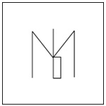

1. 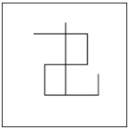
2. 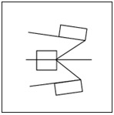
3. 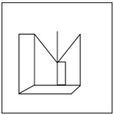
4. 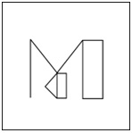

Ans. C

Sol. By carefully observing the given figure and comparing it with the four options, we can see that the exact shape and orientation of the original figure are present in option C. Rotation is not allowed, and the embedded figure in option C matches the original figure without any rotation.

Q23. Which of the following numbers will replace the question mark (?) in the given series? 165 192 227 270 321 ?

a.347

b.361

c.380

d. 392

Ans. C

Sol.

Find the differences between consecutive terms in the series:

192 - 165 = 27

227 - 192 = 35

270 - 227 = 43

321 - 270 = 51

The differences form a new series: 27, 35, 43, 51.

The second differences are constant (8), indicating a quadratic pattern.

The next difference should be 51 + 8 = 59.

Thus, the next term is 321 + 59 = 380.

Q24. 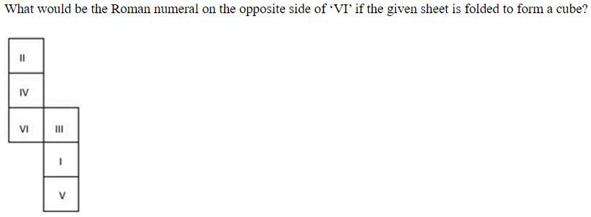

1. 
2. 
3. 
4. 

Ans. d

Sol. Match with the options by Visualling

Q25. Select the option figure in which the given figure is embedded as its part (rotation is NOT allowed)



1. 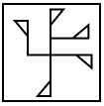
2. 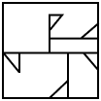
3. 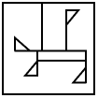
4. 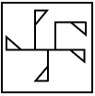

Ans. a

Sol. Match with the options